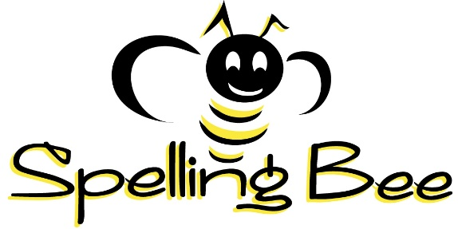
Grade One
Gr. 1: Level One – with room to put check marks (√) when practicing.
1. come |  | 14. had |  | 27. make |  | 40. tell
2. that |  | 15. not |  | 28. did |  | 41. big
3. are |  | 16. but |  | 29. way |  | 42. give
4. with |  | 17. were |  | 30. man |  | 43. keep
5. his |  | 18. your |  | 31. look |  | 44. us
6. they |  | 19. some |  | 32. here |  | 45. took
7. this |  | 20. into |  | 33. take |  | 46. got
8. have |  | 21. her |  | 34. help |  | 47. let
9. or |  | 22. two |  | 35. put |  | 48. stop
10. one |  | 23. like |  | 36. went |  | 49. add
11. ten |  | 24. copy |  | 37. care |  | 50. map
12. sad |  | 25. happy |  | 38. run
13. dog |  | 26. fall |  | 39. cat

Gr. 1: Level Two – with room to put check marks (√) when practicing.
1. what |  | 14. than |  | 27. our |  | 40. sun
2. when |  | 15. first |  | 28. day |  | 41. try
3. said |  | 16. down |  | 29. same |  | 42. room
4. out |  | 17. find |  | 30. again |  | 43. top
5. them |  | 18. may |  | 31. off |  | 44. there
6. then |  | 19. little |  | 32. away |  | 45. under
7. many |  | 20. after |  | 33. say |  | 46. draw
8. has |  | 21. back |  | 34. feet |  | 47. winter
9. more |  | 22. much |  | 35. summer |  | 48. black
10. him |  | 23. earth |  | 36. yellow |  | 49. elder
11. leaf |  | 24. snow |  | 37. side |  | 50. moose
12. spring |  | 25. good |  | 38. boy
13. time |  | 26. new |  | 39. far

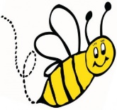
Gr. 1: Level Three – with room to put check marks (√) when practicing.
1. which |  | 51. such |  | 101. going |  | 151. days
2. their |  | 52. why |  | 102. want |  | 152. ever
3. each |  | 53. things |  | 103. school |  | 153. paper
4. about |  | 54. years |  | 104. important |  | 154. hard
5. how |  | 55. different |  | 105. until |  | 155. hear
6. these |  | 56. number |  | 106. money |  | 156. sentence
7. would |  | 57. great |  | 107. form |  | 157. better
8. other |  | 58. men |  | 108. food |  | 158. best
9. could |  | 59. small |  | 109. children |  | 159. across
10. been |  | 60. every |  | 110. land |  | 160. during
11. its |  | 61. found |  | 111. without |  | 161. today
12. who |  | 62. still |  | 112. once |  | 162. others
13. now |  | 63. between |  | 113. animals |  | 163. however
14. people |  | 64. name |  | 114. life |  | 164. sure
15. made |  | 65. should |  | 115. enough |  | 165. means
16. over |  | 66. home |  | 116. sometimes |  | 166. knew
17. only |  | 67. air |  | 117. four |  | 167. hold
18. use |  | 68. line |  | 118. head |  | 168. young
19. water |  | 69. set |  | 119. above |  | 169. left
20. long |  | 70. own |  | 120. kind |  | 170. ways
21. very |  | 71. under |  | 121. began |  | 171. thing
22. words |  | 72. read |  | 122. almost |  | 172. whole
23. called |  | 73. last |  | 123. live |  | 173. hear
24. just |  | 74. never |  | 124. page |  | 174. example
25. where |  | 75. left |  | 125. earth |  | 175. heard
26. most |  | 76. end |  | 126. need |  | 176. several
27. know |  | 77. along |  | 127. band |  | 177. change
28. through |  | 78. while |  | 128. high |  | 178. answer
29. before |  | 79. might |  | 129. hand |  | 179. sea
30. write |  | 80. next |  | 130. year |  | 180. against
31. used |  | 81. sound |  | 131. mother |  | 181. turned
32. any |  | 82. below |  | 132. light |  | 182. didn’t
33. right |  | 83. saw |  | 133. parts |  | 183. learn
34. think |  | 84. something |  | 134. country |  | 184. point
35. also |  | 85. thought |  | 135. father |  | 185. city
36. around |  | 86. both |  | 136. night |  | 186. play
37. another |  | 87. few |  | 137. following |  | 187. toward
38. came |  | 88. those |  | 138. seen |  | 188. five
39. work |  | 89. always |  | 139. picture |  | 189. using
40. three |  | 90. looked |  | 140. study |  | 190. himself
41. word |  | 91. show |  | 141. second |  | 191. want
42. must |  | 92. large |  | 142. eyes |  | 192. who
43. because |  | 93. often |  | 143. soon |  | 193. Canada
44. does |  | 94. together |  | 144. times |  | 194. group
45. part |  | 95. asked |  | 145. story |  | 195. respect
46. even |  | 96. house |  | 146. teeth |  | 196. bead
47. place |  | 97. road |  | 147. safe |  | 197. drum
48. belong |  | 98. goal |  | 148. boys |  | 198. Cree
49. ship |  | 99. don’t |  | 149. since
50. well |  | 100. world |  | 150. white

