Kindergarten
Level One – with room to put check marks (√) when practicing.
1. the |  | 13. on |  | 25. will
2. of |  | 14. as |  | 26. up
3. and |  | 15. at |  | 27. she
4. a |  | 16. be |  | 28. so
5. to |  | 17. I |  | 29. see
6. in |  | 18. by |  | 30. no
7. is |  | 19. all |  | 31. my
8. you |  | 20. we |  | 32. get
9. it |  | 21. can |  | 33. go
10. he |  | 22. an |  | 34. me
11. for |  | 23. if
12. was |  | 24. do

Level Two – with room to put check marks (√) when practicing.
1. come |  | 11. had |  | 21. make |  | 31. tell
2. that |  | 12. not |  | 22. did |  | 32. big
3. are |  | 13. but |  | 23. way |  | 33. give
4. with |  | 14. were |  | 24. man |  | 34. keep
5. his |  | 15. your |  | 25. look |  | 35. us
6. they |  | 16. some |  | 26. here |  | 36. took
7. this |  | 17. into |  | 27. take |  | 37. got
8. have |  | 18. her |  | 28. help |  | 38. let
9. or |  | 19. two |  | 29. put
10. one |  | 20. like |  | 30. went

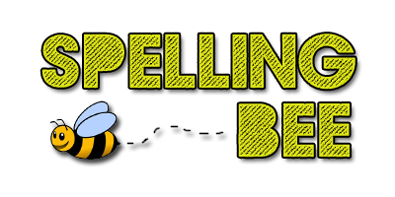

Kindergarten: Level Three – with room to put check marks (√) when practicing.
1. what |  | 11. time |  | 21. good |  | 31. side
2. when |  | 12. than |  | 22. new |  | 32. boy
3. said |  | 13. first |  | 23. our |  | 33. far
4. out |  | 14. down |  | 24. day |  | 34. sun
5. them |  | 15. find |  | 25. same |  | 35. fry
6. then |  | 16. may |  | 26. again |  | 36. room
7. many |  | 17. little |  | 27. off |  | 37. top
8. has |  | 18. after |  | 28. away
9. more |  | 19. back |  | 29. say
10. him |  | 20. much |  | 30. feet

